NEW YORK FOOTBALL GIANTS

Dear Mr. Mara, Mr. Schoen, and Mr. Daboll,

Thank you for welcoming me into the New York Giants family as an Analytics Associate. I am very eager to provide your staff with the data analysis necessary to build and manage a winning team. I’ll start by providing an explanation and visual display of my Win Probability model. This model can be leveraged for any in-game scenario (provided necessary inputs) as I will detail for the coaching changes executed during halftime of Week 2 of the 2023 Season. I’ve derived a new factor – Play-Action Impact (PAI) - to fit our offensive skillset. I will provide any limitations of my model and how it can be upgraded for future modeling scenarios. All calculations were processed in R language format and references are attached within this model package. Lastly, I will detail how the Giants can utilize win probability tables when deciding to kick an extra point or “go for 2” after a touchdown while trailing or leading in the game.

To assemble my model, I used the nflfastR package in R to analyze the all of the play-by-play data for all teams during the 2023 season². This dataset (attached) includes 49,665 observations over 372 recorded variables for all 32 teams over 17 regular season games. My model was based on the basic model created by Stephen Hill in Building a Basic, In-Game Win Probability Model for the NFL (2017)³. The purpose of my Win Probability model is to estimate the probability that our team will win a game based upon current game conditions, including: score, point differential, time remaining, down, yards to go for a first down, and total yardage needed for a touchdown. My model will use a logistic regression methodology to fit my win probability as the game progresses. I’ll then explain my derivation of factor PAI, how it applies to our offensive strategy, and factor it into my Win Probability model.

I’ve filtered the 2023 season play-by-play data by New York Giants offensive and defensive plays only. I then removed any “No Play” plays such as quarter end, penalties, or timeouts. I’ve also removed any games that went to overtime as my model only predicts winner as the game progresses in regulation time. The methodology used for my model was based on the team with possession of the football/offense vs game conditions and outcome of each play. My model also accounts for changes in the game while on defense based on the time (in seconds) remaining in regulation and any score changes³. My Win Probability model follows the below logit equation:

Poswins = β₁X₁ + β₂X₂ + β₃X₃ + β₄X₄ + β₅X₅ + β₆X₆
- Where “Poswins” tells us if the team with possession/offense ultimately wins the game
- Where each β stands for our coefficients/weighted relevance
- Where each X stands for a predictor variable: quarter, down, yards to first down, time in seconds remaining, distance from scoring a touchdown, and score difference

To measure the Win Probability model fit, I compared notable probability swings to ESPN’s win probability model for the game selected⁴. While both models accounted for the sharp decline in win probability moving below 10% as the Giants were down 0-20 at halftime, my model did not account for pre-game win probability (team rankings and previous week’s performance) and overestimated the end game probability of a loss, which I will discuss in model limitations later in this report. From 8:24 remaining in the 1st quarter to 2:23 remaining in the 4th quarter, my model follows similar peaks and valleys and is closely related to the model utilized by ESPN. Using ESPN’s model as a barometer, my model fit 85% of the total game win probability. My model’s overall standard deviation was 0.6748 and z-score value of 0.682 accounting for all game scenarios in all quarters in regulation.

The example I’ve chosen to demonstrate with my Win Probability model is Week 2 of the 2023 season when the New York Giants faced the Arizona Cardinals in Glendale, AZ. I selected this game specifically as the Win Probability model shows a vast change in the Giants probability of winning. I filtered the NYG play-by-play data, splitting into a test and training dataset. The training dataset was used to test my model, while the test dataset was put aside for other untested variables in future modeling. Below is the full-game win probability as predicted by my model:

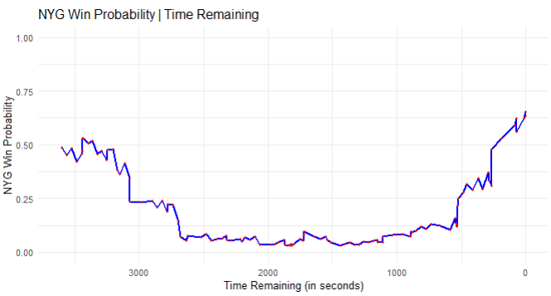
At halftime, the Giants were down 0-20 to the Cardinals and my model showed NYG win probability at 5%. During halftime, Coach Daboll and his staff made the decision to abandon the West Coast offense, 3-5 step QB drop and short slant route passes, for a play-action offense, allowing QB, Daniel Jones, to make read-option audibles on run or pass plays⁶. The play-action offense took advantage of the Cardinals defensive aggressiveness in the first half – constantly attacking the Giants offensive line to stop the run or sack the QB. The Giants offense improved from 99 total yards with an interception in the first half, to 357 total yards with 4 touchdowns and a field goal in the second half! The Giants overcame a 0-20 halftime deficit and 7-28 deficit with 4 minutes left in the 3rd quarter. My win probability model which had the Giants at 5% chance to win at halftime, slowly increased until the 4th quarter when it exponentially improved as the Giants came within one touchdown. This comeback was due in large part to the change in the offensive strategy at halftime – play-action disguised as a run play, ending in a quick pass or long crossing route⁷ exposing the Cardinals secondary⁶ - and also to the defense holding the Cardinals to only 7 points in the second half. The Giants would take the lead 31-28 on a Graham Gano field goal with 0:19 seconds to go in the 4th quarter where the model shows a 63% win probability which I’ll discuss later as a limitation of the model.
To calculate the Play-Action Impact (PAI) factor, I used the following equation based on Week 2 offensive stats as well as factoring in our opponent’s expected defensive alignment (run or pass blocking):
PAI = DA*( $\frac{YG2h-YG1h}{100}$+ 6*(TD2h-TD1h))
- Where DA is our opponent’s defensive alignment - using the Nash equilibrium as explained in Mathletics⁸, will be 60% pass defense
- Where “YG2h” is Total Yards gained in the second half
- Where “YG1h” is Total Yards gained in the first half
- Where “TD2h” is Total touchdowns in the second half
- Where “TD1h” is Total touchdowns in the first half
Using the statistics from Week 2 we have:
PAI = 0.6 *( $\frac{357-99}{100}$ + 6*(4 – 0)) = 15.948

The PAI factor was added to my Win Probability model by reducing distance to go for a touchdown by 15.948. The Win Probability model including PAI factor is below:

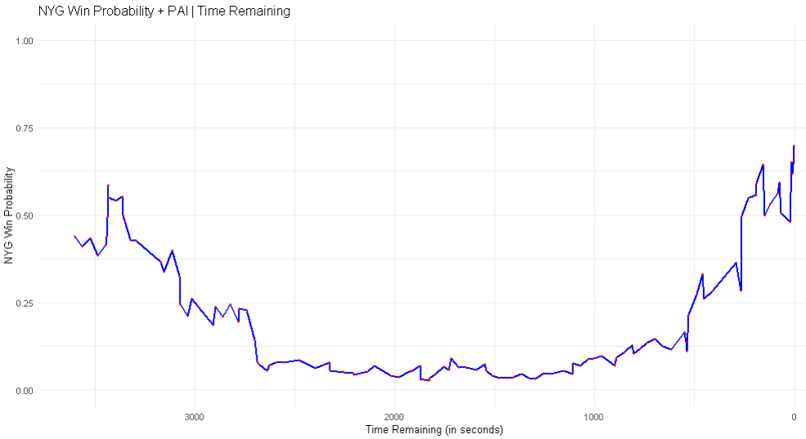

The Win Probability model + PAI factor shows more exaggerated peaks and valleys than the standard Win Probability model, but it also increases Win Probability by 6% to 70% after the Giants take the lead late in the 4th quarter. This model is also a closer fit to ESPN’s Win Probability model as it mimics the 1st changes by 12:12 left in the 1st and 4th quarter changes by 2:00 left in the 4th. This improves the model fit to 92% of ESPN’s Win Probability model.

A major limitation of both the standard and PAI + Win Probability models is not factoring the teams’ performance in prior weeks and offensive/defensive team rankings into the model for pre-game probabilities. Each model starts the game as a 50% Win Probability. Another limitation of the model is time remaining should be more heavily weighted. The Win Probability models gave the Cardinals a 36% and 30% chance to win, respectively, after the Giants took the lead 31-28 and the Cardinals only had 0:19 seconds to go downfield to win.

Future considerations to adjusting the models include: making both outputs interactive so each change in probability and play executed can be displayed by the mouse, adding home field advantage and momentum factors into the win probability equations, adjusting weighted factors of current variables, and analyzing offenses using play-action vs non-play-action for a more accurate PAI factor.

Related to win probabilities, I’d like to draw your attention to the research completed by Benjamin Morris of FiveThirtyEight.com who asked the question: [After a touchdown], “which would improve our chances of winning more, the first point or the second point?”⁸ Chapter 23 of Mathletics⁸ details Morris’s win probability changes when the size of a lead/margin of deficit changes with 10 minutes left in the game. Morris analyzed 1,897 post-touchdown decisions (including playoffs) over the 2015 and 2016 season, finding that coaches chose to go for the 2-point conversion only 107 of 690 times. The greatest frequency of coaching-decision mistakes occurs when the team is trailing by 4, 8, and 11 points. In each case, after a touchdown, the trailing team should decide to go for the 2-point conversion. When trailing by 4 points, the difference in win probability of getting +2 vs +1 points is 1.5%. When trailing by 8 points, the difference is 1.9% and trailing by 11 the difference is 0.9%. While this may seem like an insignificant change in win probability, any increased chance to win especially when trailing, is highly beneficial as shown by the Week 2 example. I have included Morris’s full decision chart in the Appendix of this package.

In conclusion, by using my Win Probability model, the Giants can determine which point during the game had a significant impact on our win probability. By including the PAI factor, I’ve provided an alternative model that includes an offensive strategy which becomes a better fit by 7% to ESPN’s Win Probability model. Limitations of each model can be minimized with additional data as detailed in my future considerations. In addition, I’ve provided a helpful resource the Giants coaching staff can utilize in-game to decide whether or not to “go for 2” after a touchdown, trailing or leading the game.

Sincerely,

Patrick Holsey

Appendix

ESPN Gamecast/Five-Thirty-Eight Win Probability from September 17, 2023. (screenshot taken close to halftime)⁴

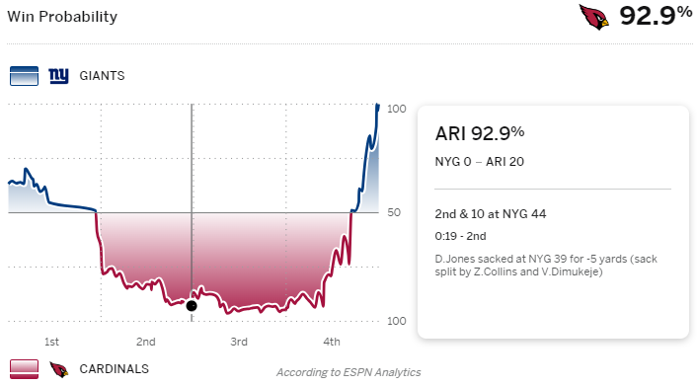

vIQsports – play-action pass offense pattern⁷ example:

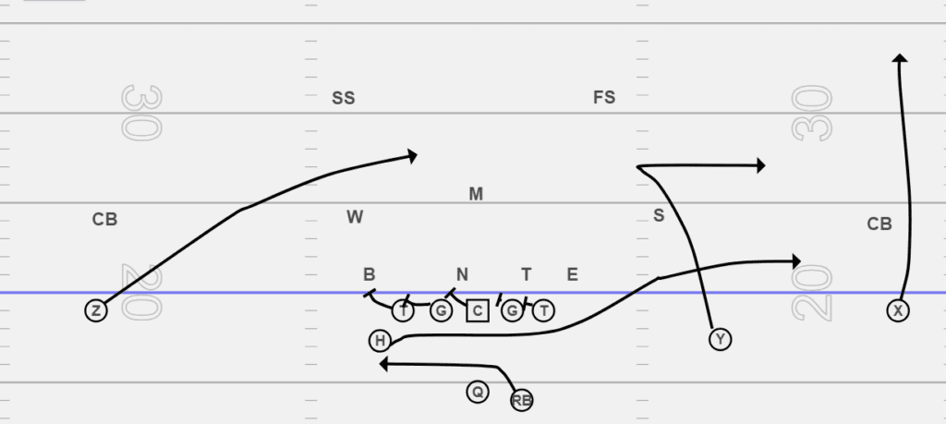

Benjamin Morris’s “How to decide when to go for 2” chart (with 10 minutes to go)⁸
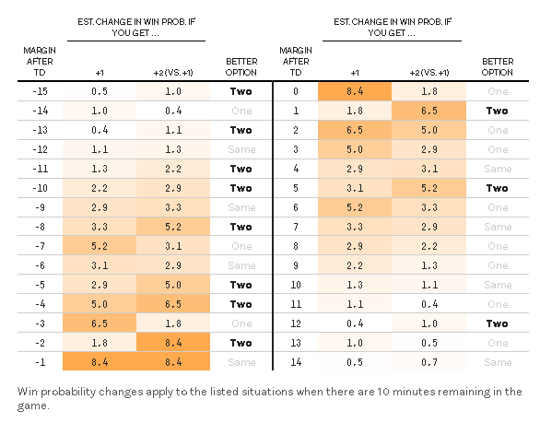

References
¹ Winston, Wayne L., Scott Nestler, and Konstantinos Pelechrinis. Mathletics: How Gamblers, Managers, and Fans Use Mathematics in Sports – Chapters 20 & 23, 2022.
² Github – NFLverse data. Play_by_play_2023.csv. https://github.com/nflverse/nflverse-data/releases/tag/pbp
³ Hill, Stephen. Building a Basic, In-Game Win Probability Model for the NFL. Medium.com, 2017. https://medium.com/@technocat79/building-a-basic-in-game-win-probability-model-for-the-nfl-54600e57fe1c
⁴ ESPN.com NFL Gamecast and Play-by-Play. Five-Thirty-Eight NFL Win Probability Pre-Game and In-Game. https://www.espn.com/nfl/game/_/gameId/401547421/giants-cardinals
⁵ Pro-Football-Reference.com 2023 New York Giants, Rosters, Stats, Schedule, Team Draftees, Injury Reports. Box Scores. https://www.pro-football-reference.com/teams/nyg/2023.htm#all_games
⁶ Lee, Michael. How the New York Giants Helped Their Offensive Line. SI.com, 2023. https://www.si.com/nfl/giants/gameday/how-giants-helped-oline
⁷Haddad, Chris. Difference Between Play Action & RPO In Football. vIQtorysports.com, 2024. https://www.viqtorysports.com/play-action-rpo-read-option/#:~:text=The%20difference%20between%20the%20play,confusing%20to%20the%20naked%20eye.
⁸Morris, Benjamin. When To Go For 2, For Real. FiveThirtyEight.com, 2017. https://fivethirtyeight.com/features/when-to-go-for-2-for-real/

